Requirement Analysis
Solution Requirements (Functional & Non-functional)
Date | 8 October 2026
Student Name | OviyaShree
Project Name | Metro Ticket Generating System in ServiceNow
Maximum Marks

Functional Requirements
FR No. | Functional Requirement (Epic) | Sub Requirement
FR-1 | Ticket Booking Catalog Item | Service Catalog item with variables Source, Destination, Passenger Type and Number of Tickets.
FR-2 | Field Validation | Non-empty source/destination, fare match and approved travel date.
FR-3 | Mandatory Fields | Enforced on client and server side to prevent incomplete submissions.
FR-4 | Auto-Populate Logic | Default values (e.g., single or return journey) using catalog client scripts and UI policies.
FR-5 | Fare Calculation | Fare is calculated automatically from stations, passenger type and number of tickets.
FR-6 | QR Code Generation | A digital ticket with a QR code is generated instantly after booking.
FR-7 | Station Details Mapping | Station details are mapped to the booking for fare and validation.
FR-8 | Field Mapping | Process Automation Engine auto-maps and populates values entered by the user.
FR-9 | Notifications | Booking confirmation sent through Flow Designer and Notifications.
FR-10 | UI Pages & Testing | User-facing UI pages, followed by UAT and deployment.
Non-functional Requirements
NFR | Requirement | Description
NFR-1 | Usability | Simple and fast booking form for all passengers.
NFR-2 | Security | ServiceNow platform and role-based access controls.
NFR-3 | Reliability | Validation rules consistently prevent incomplete or wrong bookings.
NFR-4 | Performance | Normal interactive ServiceNow response for booking and QR generation.
NFR-5 | Availability | Depends on the ServiceNow instance.
NFR-6 | Scalability | Extendable with payments, analytics and WhatsApp booking.
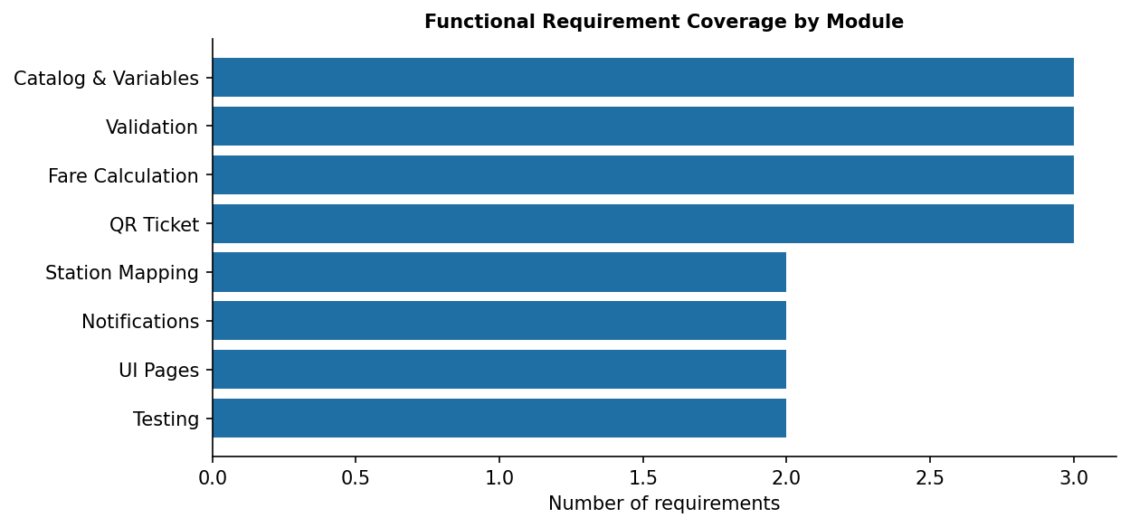
Figure 1: Functional requirement coverage.

